

CSE523: Machine Learning

Faculty: Professor Mehul Raval

Group Name.: Code Rockers

Face Recognition & Attendance System

(Report File)

Harsh Rathod – AU1940196

Sushan Bhojak – AU1940200

Priya Bhoraniya – AU1940173

Dhruvanshu Parmar – AU1940166

1. **Task performed in the week:**

* We can detect face from train images and after running code test image shows rectangle with name on face.

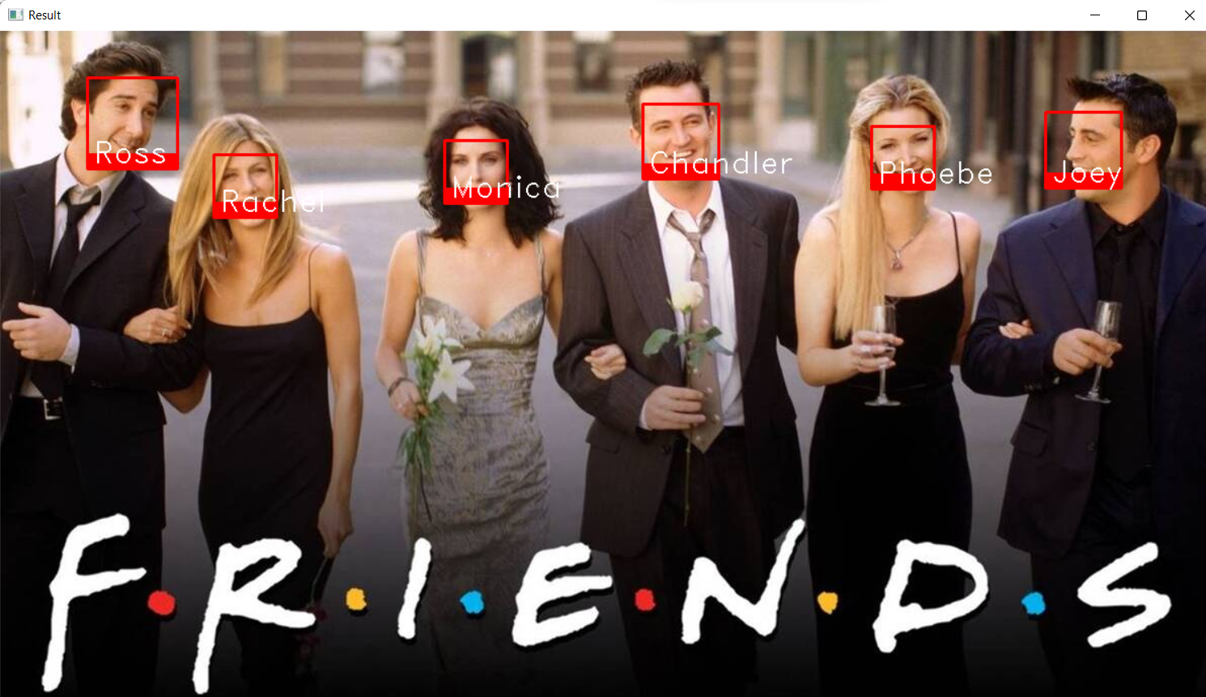

**Task to be performed next week:**

* We will focus on algorithms and method.